## **Pegasi mediation others ads Doc、**

1. Import ads jar or aar in you project;

Eclipse Import jar:

Right click on you project and then build path ----> add build path

Android studio import jar:

In Gradle file you shoud add : compile fileTree(dir: 'libs', include: ['*.jar'])

Import aar

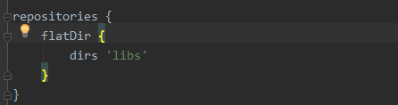



1. Create a new Package the Package name is “com.cmcm.adsdk.adapter”,and then put the xxxAdapter.java into this package.

Note:if you access mopub ads you must add AdvertisingIdHelper.java、 AdvertisingIdInterface.java、GooglePlayServiceConnection.java into “com.cmcm.adsdk.adapter”

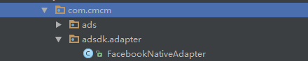

1. Add this code after that Pegasi sdk init；

If you need mopub ads you shuold add this code :

CMAdManager.getFactory().addLoaderClass("mp", "com.cmcm.adsdk.adapter.MopubNativeAdapter");

If you need Facebook ads you should add this code:

CMAdManager.getFactory().addLoaderClass("fb", "com.cmcm.adsdk.adapter.FacebookNativeAdapter");

If you need Admob ads you should add this code:

CMAdManager.getFactory().addLoaderClass("ad", "com.cmcm.adsdk.adapter.AdmobNativeAdapter");

If you need yahoo ads you should add this code:

CMAdManager.getFactory().addLoaderClass("yh", "com.cmcm.adsdk.adapter.YahooNativeAdapter");

4、Add confusion script

If you access mopub ads you should add this confusion script:

-keep class com.cmcm.adsdk.adapter.MopubNativeAdapter{ *; }

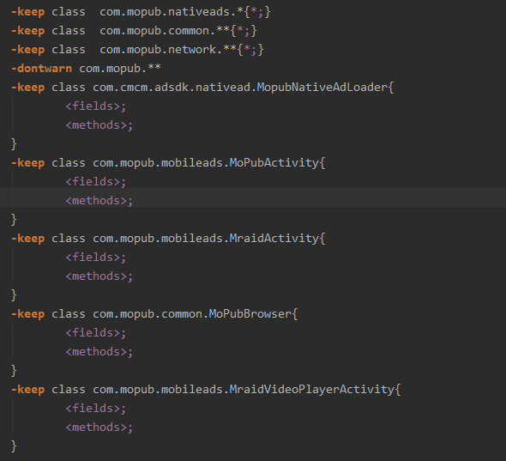

If you access facebook ads you should add this confusion script:

-keep class com.cmcm.adsdk.adapter.FacebookNativeAdapter{ *; }

If you access admob ads you should add this confusion script:

-keep class com.cmcm.adsdk.adapter.AdmobNativeAdapter{ *; }

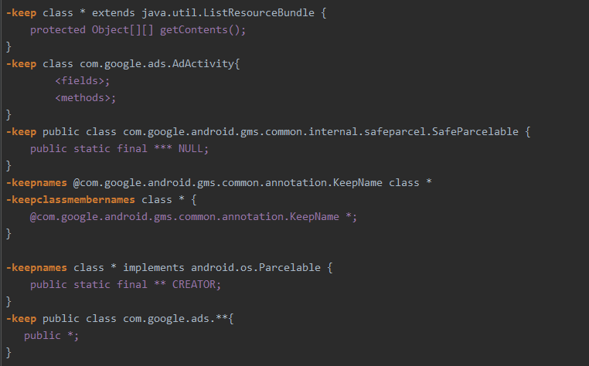

If you access yahoo ads you should add this confusion script:

-keep class com.cmcm.adsdk.adapter.YahooNativeAdapter{ *; }

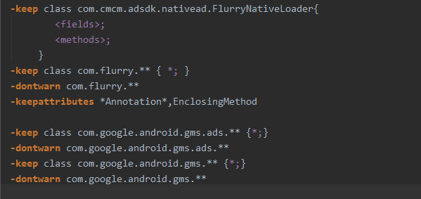

Note ： the detail confusion script you can refernce Pegasi demo.